DBMS PROJECT

CONTENTS

* SCHEMAS
* QUERIES
* ER DIAGRAM
* NORMALISED TABLE

TABLES IN THE PROJECT

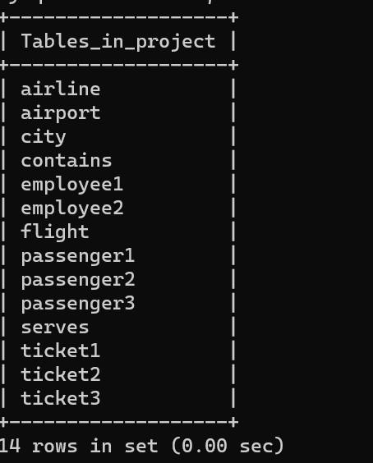

TABLE 1

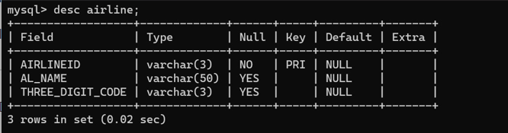

TABLE 2

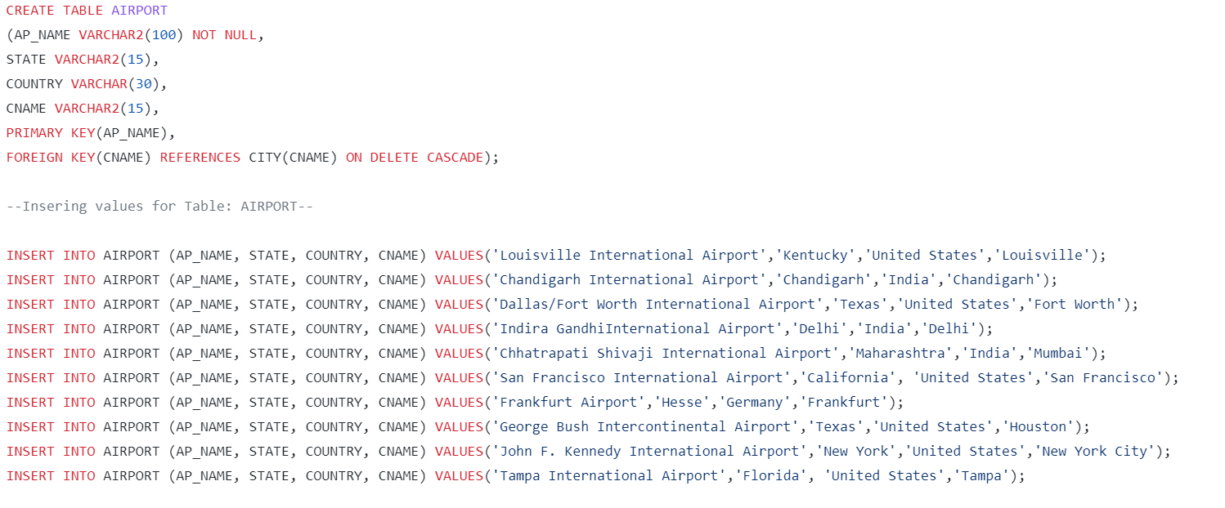

TABLE 3

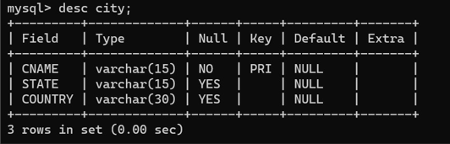

TABLE 4

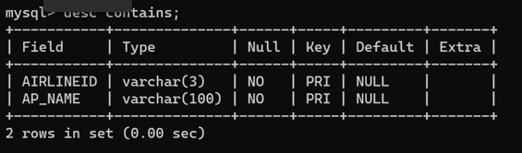

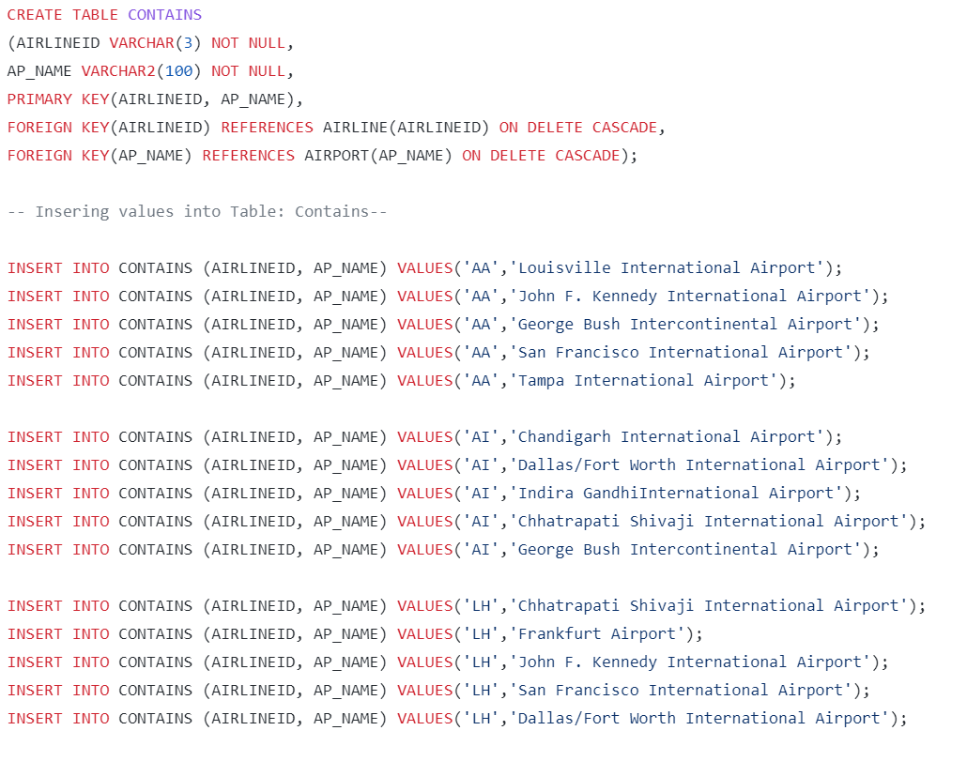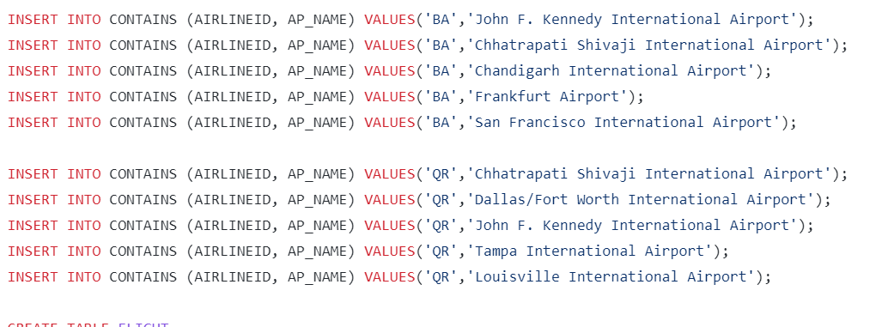

TABLE 5

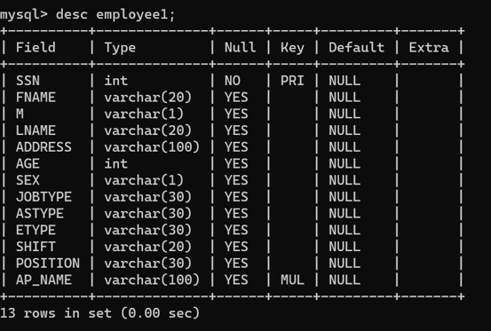

TABLE 6

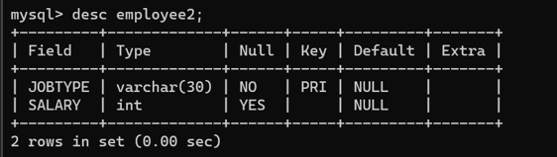

TABLE 7

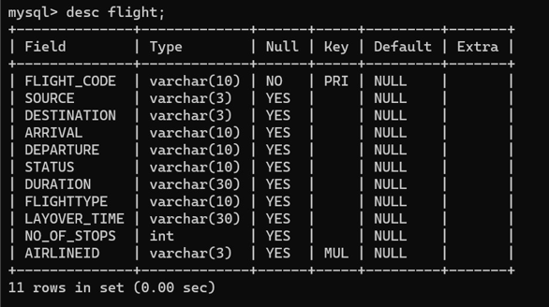

TABLE 8

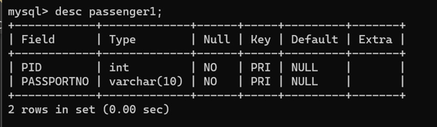

TABLE 9

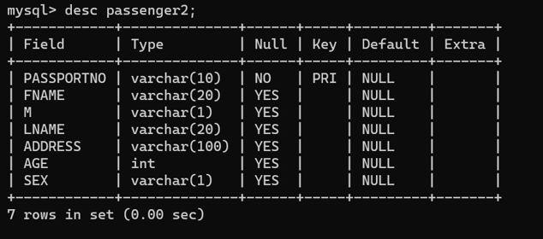

TABLE 10

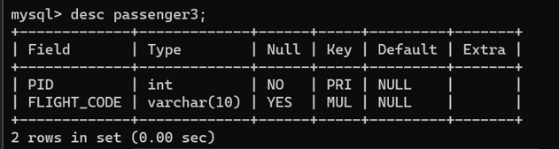

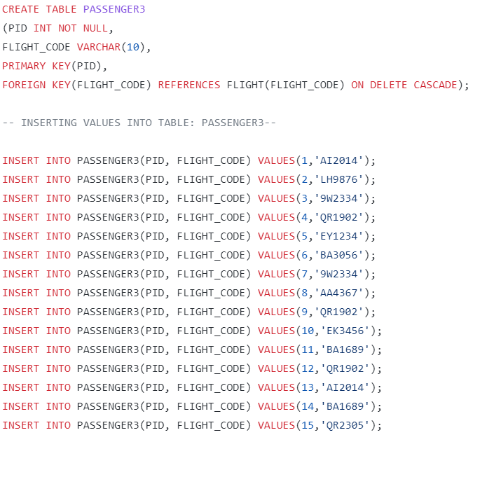

TABLE 11

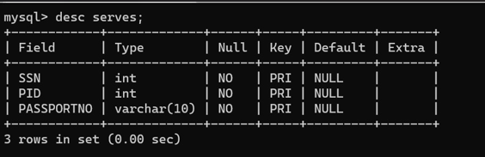

TABLE 12

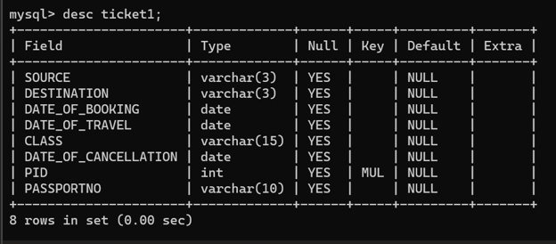

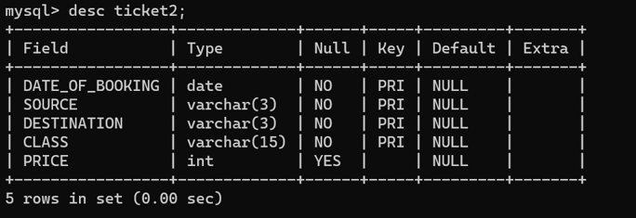TABLE 13

TABLE 14

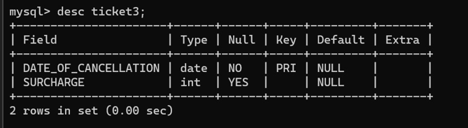

QUERIES

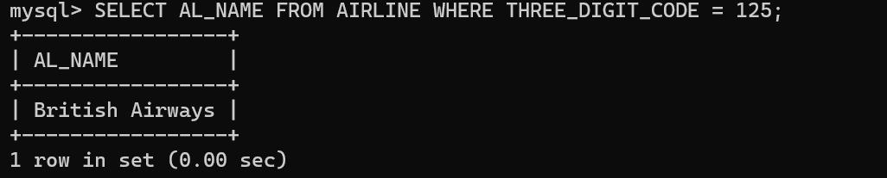

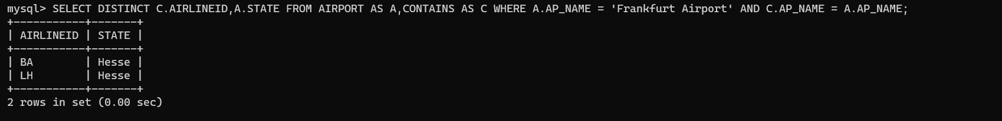

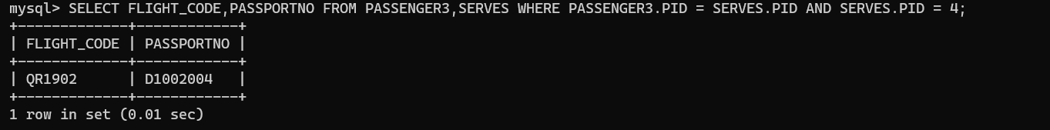

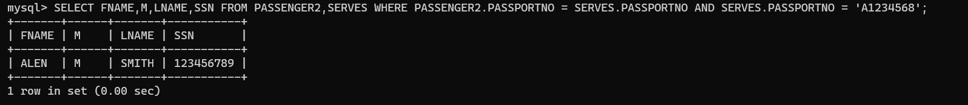 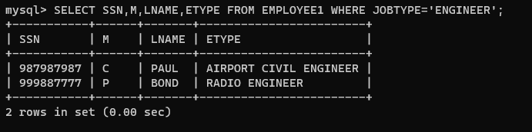

ER DIAGRAM

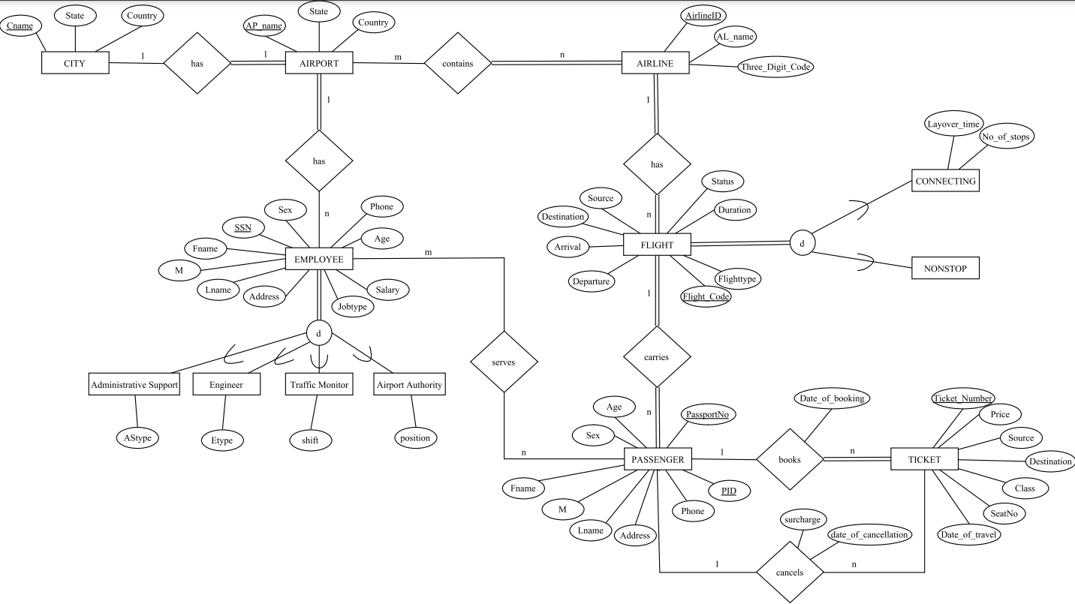

NORMALISED TABLE

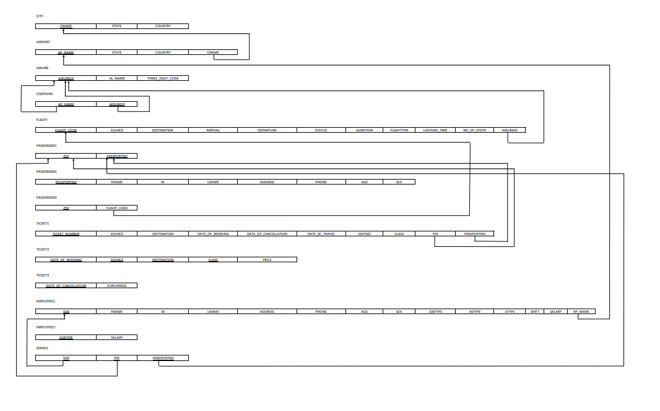

THANK YOU